13.2.5 Participant Windows

The Windows section contains a list of the functional groups and a brief description of each.

Note that New Mexico Medicaid refers to participants as “clients.” The PDCSOS PLUS base system uses the term “participant” as synonymous with client, member, beneficiary, etc.
Note: Participant data is entered and maintained on the OmniCaid MMIS for New Mexico. All data within the PDCSOS PLUS Participant subsystem for NEWMEX and NMENCO is read-only and fields is indicated within the specifications tables as “always protected” and “conditionally required” based upon the data received from the MMIS.

The following are a list of windows within the Point of Sale (PDCS OS PLUS) Participant subsystem:

- The Search Tab Page window utilizes Participant Search criteria to locate a desired participant.

- The Member Tab Page window contains the participant’s demographic and eligibility information.

- The Address Tab Page window contains the participant’s address and telephone information.

- The Plan Coverage Tab Page window contains the participant’s current and historical Plan Coverage eligibility spans. Note that the Nursing Home pane on this tab is not being utilized for New Mexico.

- The Lock-In Tab Page window contains current and historical Lock-In data for the participant.

- The COB Tab Page window contains the participant’s current and historical third party liability (TPL) coverage information.

- The Alternate ID Tab Page window contains any and all alternate IDs for the participant. Note that the ID Cards pane on this tab is not being utilized for New Mexico.

- The Benefit Limits Tab Page window displays information about the participant’s benefit maximums and deductibles.

- The Injury Tab Page window is used for Conduent’s Workers Compensation Customers and is not applicable for New Mexico.

- The Seniors Tab Page window is used for Conduent’s Senior Pharmacy Benefit Customers and is not applicable for New Mexico.

Each of these windows is described in detail separately below.
Participant Functional Group

This functional group provides the user the ability to:

- Inquire on participant information

The following tab windows are used by the Participant Functional Group:

- Search
- Member
- Address
- Plan Coverage
- Lock-in
- COB
- Alternate ID
- Benefit Limits
- Injury
- Seniors

The following data is displayed in the title bar of all tab windows (i.e., not on search windows) in this functional group:

- Customer
- Participant Name and ID
- Member Code

New Mexico PDCS OS PLUS Participant Subsystem
Window Specification
Participant Functional Group
Participant Search Tab Page

Window Name: Participant: Search Tab
Description:
The Participant Search window is the first window that appears when the Participant Subsystem is selected from the Subsystem Menu .The user may enter selection criteria to locate an existing participant.

A participant search can be performed using Participant ID, Social Security Number, or Last Name.

Participant ID search: Any of the various IDs that are applicable for the participant can be used for a Participant ID search .The system does not allow partial searches for participant ID within the NEWMEX or NMENCO Customers .When the user enters an available ID, the system then adds leading zeros to the left side of the ID in order to make the field entry 14 digits . The 14-digit number is then sent to the MMIS for a Participant ID eligibility search query .(Example 1 – User enters 39478493 in the Participant ID search criteria .The system pads the value to 00000039478493 .Example 2 – User enters 3000383292 .The system pads the value to 00003000383292.)

Name Search: A partial search can be performed on a Last Name search .For this search the user is required to enter at least three characters followed by a wild card (%) .(Example – User must enter [ Smi% ] to retrieve all participants with the last name Smith .The search can also be performed using First Name, Middle Initial, Birth Date, Gender, and/or Race qualifiers to further refine the search results.

SSN: The GUI does not allow partial searches for SSN .The user must enter all nine digits of the SSN.

If only one participant matches the search criteria entered, that record is displayed on the Member Information window .

If multiple participants match the search criteria, the first 500 records display in the Participant Search list box .The user may scroll through the list of participants until the desired record is located . To select a participant for display, the user must click the Participant ID link .

Window Type:
Response window

Navigation:
The user enters this window by clicking on the Participant option on the PDCS OS PLUS subsystem menu or by clicking on the Search tab on any of the Participant subsystem windows .This window takes the user to the Member Information window if a single participant matches the search criteria or if a participant is selected from the results list .If the Add Participant link is clicked, a blank Participant window is displayed for data entry.

Interface to other subsystem(s):
The user may view claim records for the participant from this window by clicking on the Show Claims link at the far right on each record line returned in the search results set .This option displays the Claim Inquiry Search window for the selected participant .Upon completion of claim review, the user may return to the Participant window by clicking on the Return to Participant link at the top right of the Claim Inquiry window.

Interface to other Application(s):
Participant data is entered and maintained on the OmniCaid MMIS for New Mexico .When a Participant record is searched, PDCSOS PLUS sends a realtime eligibility request to the MMIS, and Participant data within PDCSOS PLUS is then populated based on the MMIS participant eligibility records.
Special Security Requirements:
N/A

Presentation Sequence(s):
The Search By criteria determines the initial sequence of data presented .The search results may be resorted into Participant ID, ID Code, Name, Gender, or Race sequence by clicking on the column heading .

Note: New Mexico has two separate Customer IDs in PDCSOS PLUS. NEWMEX accommodates Fee-For-Service (FFS) plans, and NMENCO accommodates managed care (MCO) plans .A participant (client) in New Mexico Medicaid may have active coverage in an FFS plan and an MCO plan, and both may be active at the same time .The PDCSOS PLUS eligibility interface lists participants with all types of plans on the participant search results list, but when the user selects a participant from the result set, that participant is only displayed if he or she has ever been covered under the current active Customer ID chosen upon PDCSOS PLUS login .So if a user is viewing data within the NMENCO customer, it is not possible to display details for a participant who has never had MCO coverage .Likewise, a user viewing NEWMEX Customer data cannot display details for a participant who has never had FFS coverage .Coverage does not have to be currently active as long as it exists in a participant’s history .Thus when a specific participant is selected from the results set, the system checks to ensure that the participant has (or has had) active coverage under the applicable program .If this is not the case, an error message is displayed.

Note that the PDCSOS PLUS Participant windows only display Plan Coverage details applicable to the Customer ID chosen at login; thus a user signing in to the NEWMEX Customer only sees information about a participant’s Medicaid FFS plans, whereas a user signing in to the NMENCO Customer only sees a participant’s MCO plans.

Remarks:
Participant data is entered and maintained on the OmniCaid MMIS for New Mexico. All data within the PDCSOS PLUS Participant subsystem for NEWMEX and NMENCO is read-only.

New Mexico PDCS OS PLUS Participant Subsystem
Window Layout
Participant Functional Group
Participant Search Tab

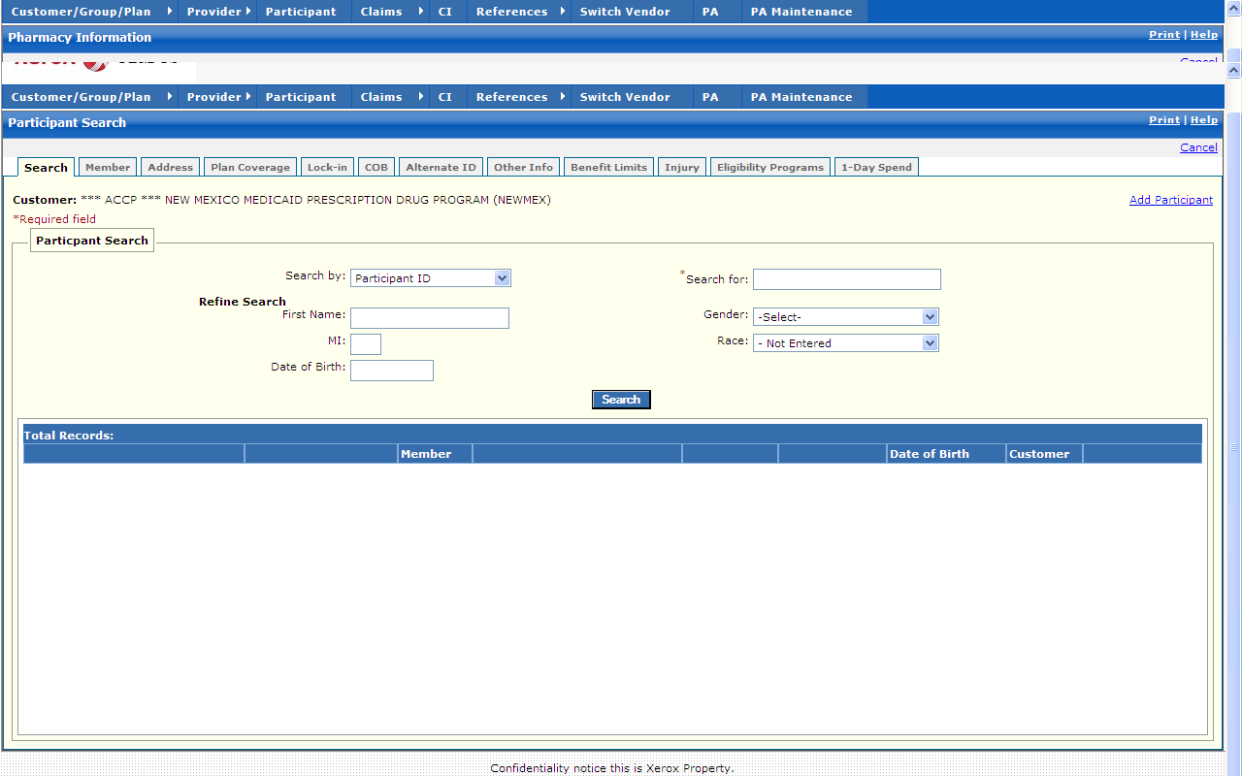

New Mexico PDCS OS PLUS Participant Subsystem
Window Exhibit
Participant Functional Group
Participant Search Tab Page
Field Name | Table  Column Name | Table Name | Format | Prot (A,C,N) | Req.  (A,C,N) | Std. Edits | Specifications | Note  Ref
Customer | R-CUST-PART-NUM | B_DETAIL_NM | 9,999 | A | N/A | N/A | Display Header
Add Participant | N/A | N/A | Link | A | N | N/A | Selecting the Add Participant link takes the user to a blank Member tab page for data entry. | C1
Participant Search Entry | Group | N/A | Free Form | N/A | N/A | N/A | Grouping
Search by | N/A | N/A | Drop-down | N | AN | VN/A | Search by defaults to Participant ID .SSN, Medicare Id & Last Name are other Search by options.
Search for | N/A | N/A | N/A | N | A | N/A | Wild card (%) search can be invoked for name searches only using three or more characters followed by a wild card (%). | C2
Refine Search | Group | N/A | Grid | N/A | N/A | N/A | An Entry in this section is used to refine the search.
First Name | B_FST_NAM | B_DETAIL_NM | X (30) | N | N | N/A | Participant’s first name used to refine the search.
MI | B_MI_NAM | B_DETAIL_NM | X (1) | N | N | N/A | Participant’s middle initial used to refine the search.
Date of Birth | B_DOB_DT | B_DETAIL_NM | DATE | N | CN | D | Participant’s date of birth used to refine the search.
Gender | B_GENDER_CD | B_DETAIL_NM | Drop-down | N | N | V | Participant’s gender used to refine the search.  Valid Value list 0229
Race | B_RACE_CD | B_DETAIL_NM | X (9) | N | N | N/A | Participant’s race used to refine the search.
Command Button | Group | N/A | Free  Form | N/A | N/A | N/A | Grouping
Search | N/A | N/A | Push Button | N | A | N/A | When selected, this button searches the Participant database for selected customer to match the criteria entered in the Search By and Search For criteria fields.
Participant Search Display | Grouping |  | Free Form | N/A | N/A | N/A | Grouping
Participant ID | B_ALT_ID | B_ALT_ID_TB | X (20) | A | N | N/A | Participant ID returned as a result of the search. | C3
ID Code | B_ALT_ID_CD | B_ALT_ID_TB | X (2) | A | N | N/A | Qualifier associated with the Participant IDs  Valid Values List 0255
Member | N/A | N/A | Display | A | N | N/A | Not captured for New Mexico .Always “1” for New Mexico .No multiple members.
Name | B_LAST_NAM  B_FST_NAM  B_MI_NAM | B_DETAIL_NM  B_DETAIL_NM  B_DETAIL_NM | X (35)  X (30)  X (1) | A | N | N/A | Participant Name returned as a result of the search.
Gender | B_GENDER_CD | B_DETAIL_NM | X (1) | A | N | N/A | Participant gender returned as a result of the search.  Valid Value list 0229
Race | B_RACE_CD | B_DETAIL_NM | X (9) | N | N | N/A | Participant gender returned as a result of the search.
Date of Birth | B_DOB_DT | B_DETAIL_NM | DATE | A | N | N/A | Participant date of birth returned as a result of the search.
Customer | R_CUST_NAM & R_CUST_ID | R_CUST_DTL_TB | Display | A | N | N/A | This field is populated based on the Customer ID chosen upon login.
Total Records | N/A | N/A | Display | A | N/A | N/A | Computed as total number of participants meeting the search criteria

Legend
Prot. and Req. | Standard Edits | Note Ref.
A = Always | D = Date Edit | C = Customer-specific field or functionality
C = Conditionally | N = Numeric Edits | R = Note Reference
N = Never | S = System Generated
 | V = Valid Value Edit

Ref. No. | Notes
C1 | Participant data is entered and maintained on the OmniCaid MMIS for New Mexico. All data within the PDCSOS PLUS Participant subsystem for NEWMEX and NMENCO is read-only; if a Participant must be manually added for immediate coverage, this is done within the MMIS, and is immediately accessible within PDCSOS PLUS via the realtime eligibility interface with OmniCaid.
C2 | For New Mexico, the system does not allow partial searches for Participant ID or SSN.
C3 | New Mexico has two separate Customer IDs in PDCSOS PLUS. NEWMEX accommodates Fee-For-Service (FFS) plans, and NMENCO accommodates managed care (MCO) plans .A participant (client) in New Mexico Medicaid may have active coverage in an FFS plan and an MCO plan, and both may be active at the same time .The PDCSOS PLUS eligibility interface lists participants with all types of plans on the participant search results list, but when the user selects a participant from the result set, that participant is only displayed if he or she has ever been covered under the current active Customer ID chosen upon PDCSOS PLUS login .So if a user is viewing data within the NMENCO customer, it is not possible to display details for a participant who has never had MCO coverage .Likewise, a user viewing NEWMEX Customer data cannot display details for a participant who has never had FFS coverage .Coverage does not have to be currently active as long as it exists in a participant’s history .Thus when a specific participant is selected from the results set, the system checks to ensure that the participant has (or has had) active coverage under the applicable program .If this is not the case, an error message is displayed.
New Mexico PDCS OS PLUS Participant Subsystem
Window Specification
Participant Functional Group
Member Tab Page

Window Name: Participant: Member Tab
Description:
The Member Information page displays when an existing participant is selected for inquiry. It contains two panes.

The Member Information pane contains demographic information about the participant including name, gender, birth date, date of death, social security number, and card issue date.

The Member Eligibility pane contains the current, future, and historical time spans for the participant’s eligibility to participate in a pharmacy benefit program .A voided span is ignored by claims processing .

Window Type:
Response window

Navigation:
The user enters this window by either entering search criteria that are unique for a participant on the Participant Search window, by selecting a participant from the Participant Search list, or by clicking on the Member tab on any of the Participant subsystem windows .Clicking on the Show Last Update link displays the Update Information window.

Interface to other subsystem(s):
The user may view claim records for the participant from this window by clicking on the Show Claims link .This option displays the Claim Inquiry Search window for the selected participant .Upon completion of claim review, the user may return to the Participant window by clicking on the Return to Participant link at the top right of the Claim Inquiry window.

Interface to other Application(s):
Participant data is entered and maintained on the OmniCaid MMIS for New Mexico .When a Participant record is searched, PDCSOS PLUS sends a realtime eligibility request to the MMIS, and Participant data within PDCSOS PLUS is then populated based on the MMIS participant eligibility records.

Special Security Requirements:
N/A

Presentation Sequence(s):
The eligibility spans are displayed in descending "begin date sequence.”
Note that eligibility information is populated based on the composite of a participant’s plan coverage spans.

Remarks:
Participant data is entered and maintained on the OmniCaid MMIS for New Mexico. All data within the PDCSOS PLUS Participant subsystem for NEWMEX and NMENCO is read-only.
New Mexico PDCS OS PLUS Participant Subsystem
Window Layout
Participant Functional Group
Member Tab Page

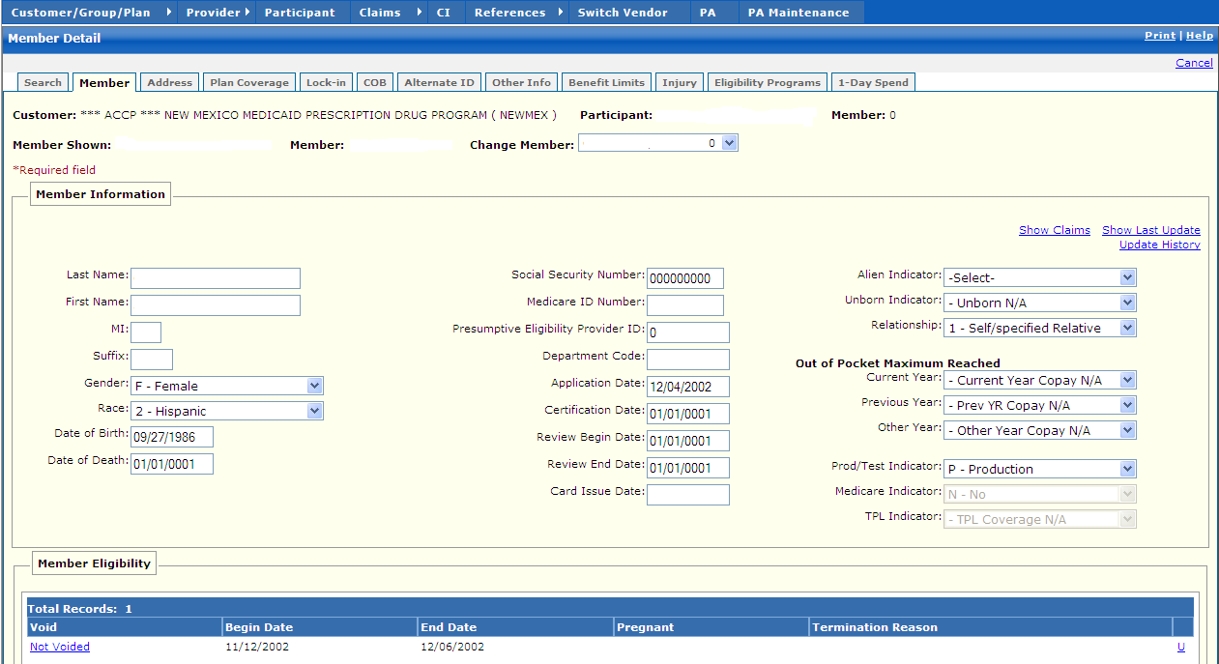
Note: Some screenshots within this and other sections containing participant data have been made using test IDs devoid of PHI .
In some cases, real data has been used with PHI masked to demonstrate important New Mexico functions.

New Mexico PDCS OS PLUS Participant Subsystem
Window Exhibit
Participant Functional Group
Member Search Tab Page
Field Name | Table  Column Name | Table Name | Format | Prot  (A,C,N) | Req.  (A,C,N) | Std. Edits | Specifications | Note  Ref
Customer | R-CUST-PART-NUM | B_DETAIL_NM | 9,999 | A | N/A | N/A | Display Header
Participant | B_ALT_ID | B_ALT_ID_NM | Display | N | N | N/A | This is the single unique participant chosen from the results
Member | N/A | N/A | Display | A | N | N/A | Not captured for New Mexico .Always “1” for New Mexico .No multiple members.
Member Shown | N/A | N/A | N/A | N/A | N/A | N/A | N/A
Member | N/A | N/A | N/A | N/A | N/A | N/A | N/A
Change Member | N/A | N/A | N/A | N/A | N/A | N/A | N/A
Member Information | Group | N/A | N/A | N/A | N/A | N/A | Grouping
Show Claims | N/A | N/A | Link | N | N | N/A | By selecting Show Claims Link, all claims for the selected member is displayed under Claims Inquiry. The user may then return to the Participant record by selecting the “Return to Participant” link at the top right of the Claim Inquiry window,
Show Last Update | N/A | N/A | Link | N | N | N/A | By selecting Show Last Update Link, a pop-up window is displayed showing User ID, Date and Time of when the record was initially created, and when it was last updated.
Last Name | B_LAST_NAM | B_DETAIL_NM | X (35) | A | CN | N/A | Participant last name
First Name | B_FST_NAM | B_DETAIL_NM | X (30) | A | N | N/A | Participant first name
MI | B_MI_NAM | B_DETAIL_NM | X (1) | A | N | M/A | Participant middle initial
Suffix | B_SFX_NAM | B_DETAIL_NM | X (3) | A | N | N/A | Participant name suffix | Not used for New Mexico
Gender | B_GENDER_CD | B_DETAIL_NM | Drop-down | AA | CN | N/AV | Participant gender code  Valid Values List 0229
Race | B_RACE_CD | B_DETAIL_NM | X (9) | N | N | N/A | Participant gender returned as a result of the search.
Date of Birth | B_DOB_DT | B_DETAIL_NM | DATE | A | N | N/A | Must be a valid date
Date of Death | B_DOD_DT | B_DETAIL_NM | DATE | A | N | N/A | Must be a valid date
Social Security Number | B_SSN_NUM_TX | B_DETAIL_NM | X (9) | A | N | N/A | Participant Social Security Number
Medicare ID Number | B-MCARE-ID | BMCARETB | X (10) | A | N | N/A | Participant Medicare ID Number
Presumptive Eligibility Provider ID | N/A | N/A | N/A | N/A | N/A | N/A | Not captured for New Mexico .
Department Code | N/A | N/A | N/A | N/A | N/A | N/A | Not captured for New Mexico .
Application Date | B_APPL_DT | B_DETAIL_NM | DATE | A | N | N/AN/A | Must be a valid date
Certification Date | B_CERT_DT | B_DETAIL_NM | DATE | A | N | N/AN/A | Must be a valid date
Review Begin Date | B_ON_REVW_BEG_DT | B_DETAIL_NM | DATE | A | N | N/AN/A | Must be a valid date
Review End Date | B_ON_REVW_END_DT | B_DETAIL_NM | DATE | A | N | N/A | Must be a valid date
Card Issue Date | B_ID_ISSUE_DT | B_DETAIL_NM | DATE | A | N | N/A | Must be a valid date
Alien Indicator | N/A | N/A | N/A | N/A | N/A | N/A | Not captured for New Mexico .
Unborn Indicator | N/A | N/A | N/A | N/A | N/A | N/A | Not captured for New Mexico .
Relationship | N/A | N/A | N/A | N/A | N/A | N/A | Not captured for New Mexico . Defaulted to “1” for New Mexico
Out of Pocket Maximum Reached | Group | N/A | Free Form | N/A | N/A | N/A | Grouping
Current Year | N/A | N/A | N/A | N/A | N/A | N/A | Mainframe calculated
Previous Year | N/A | N/A | N/A | N/A | N/A | N/A | Mainframe calculated
Other Year | N/A | N/A | N/A | N/A | N/A | N/A | Mainframe calculated
Prod/Test Indicator | N/A | N/A | N/A | N/A | N/A | N/A | Allows the entry of “test” participants .Defaults to “P” for New Mexico | C1
Medicare Indicator | B_MCARE_CD | B_MCARE_TB | Drop-down | AA | CN | N/AV | Valid Values List 5295
TPL Indicator | B_TPL_IND | B_DETAIL_NM | X (1)  Drop-down | A  A | N | N/AV | Participant has TPL ind.  Valid Values List 9380
Member Eligibility Display | Group | N/A | N/A | N/A | N/A | N/A | Grouping
Void | B_ELIG_VD_IND | B_MBR_TB | DisplayX(1) | A | N | N/A | Voided record indicator  Valid Values List 2670
Begin Date | B_MBR_BEG_DT | B_MBR_TB | DATE | A | N | N/A | Participant eligibility begin date
End Date | B_MBR_END_DT | B_MBR_TB | DATE | A | N | N/A | Participant eligibility end date
Pregnant | N/A | N/A | N/A | N/A | N/A | N/A | Not captured for New Mexico .
Termination Reason | B_TERM_RSN_CD | B_MBR_TB | X (2) | A | N | N/A | Participant’s reason for termination  Valid Values List 8583
Total Records | N/A | N/A | N/A | A | N | N/A | Computed as total number of member eligibility segments
Member Eligibility Entry | Group | N/A | Free Form | N/A | N/A | N/A | Grouping
Void Indicator | B_ELIG_VD_IND | B_MBR_TB | X (1)  Drop-down | AN | N | N/AV | Voided record indicator  Valid Values List 2670
HH Alternate ID | B_HH_ALT_ID | B_MBR_TB | X (2)  Drop-down | N/AN | N/AN | N/AN/A
Begin Date | B_MBR_BEG_DT | B_MBR_TB | DATE | A | A | N/AN/A | Must Be a valid date
Termination Reason | B_TERM_RSN_CD | B_MBR_TB | Drop-down | AN | CN | N/AV | Participant’s reason for termination  Valid Values List 0255
End Date | B_MBR_END_DT | B_MBR_TB | DATE | A | A | N/A | Must Be a valid date

Legend
Prot. and Req. | Standard Edits | Note Ref.
A = Always | D = Date Edit | C = Customer-specific field or functionality
C = Conditionally | N = Numeric Edits | R = Note Reference
N = Never | S = System Generated
 | V = Valid Value Edit

Ref. No. | Notes
C1 | The Prod/Test indicator is not used for New Mexico .The Participant subsystem is completely view-only.

New Mexico PDCS OS PLUS Participant Subsystem
Window Specification
Participant Functional Group
Address Tab Page

Window Name: Participant: Address Tab
Description:
This tab page maintains multiple types of addresses related to a participant, including mailing address, physical address, and residential address .Space is also available for a county code, e-mail address, telephone number, and fax number for each participant address type.

Window Type:
Response window

Navigation:
The user enters this window by selecting the Address tab from any of the Participant Subsystem windows .Clicking on the Last Update link displays the Update Information window for the address in question.

Interface to other subsystem(s):
N/A

Interface to other Application(s):
Participant data is entered and maintained on the OmniCaid MMIS for New Mexico .When a Participant record is searched, PDCSOS PLUS sends a realtime eligibility request to the MMIS, and Participant data within PDCSOS PLUS is then populated based on the MMIS participant eligibility records.

Special Security Requirements:
N/A

Presentation Sequence(s):
The addresses display in ascending address type code sequence .

Remarks:
Participant data is entered and maintained on the OmniCaid MMIS for New Mexico. All data within the PDCSOS PLUS Participant subsystem for NEWMEX and NMENCO is read-only.

New Mexico PDCS OS PLUS Participant Subsystem
Window Layout
Participant Functional Group
Address Tab Page

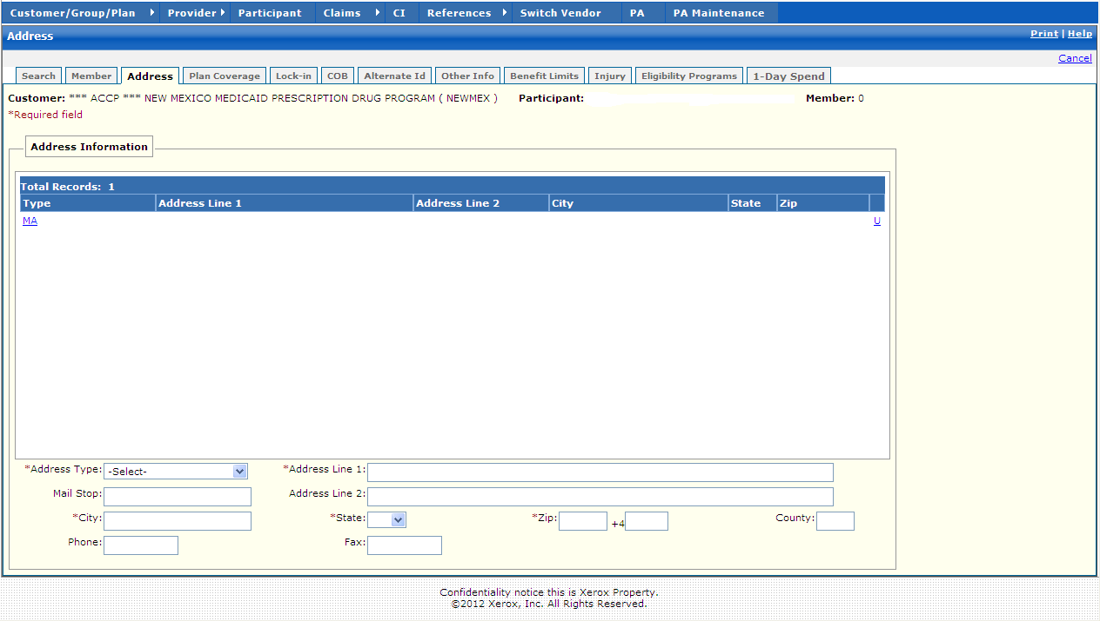

New Mexico PDCS OS PLUS Participant Subsystem
Window Exhibit
Participant Functional Group
Address Tab Page
Field Name | Table  Column Name |  | Table Name | Format | Prot  (A,C,N) |  | Req.  (A,C,N) |  | Std. Edits |  | Specifications | Note  Ref
Customer | R-CUST-PART-NUM |  | B_DETAIL_NM | 9,999 | A |  | N/A |  | N/A |  | Display Header
Participant | B_ALT_ID |  | B_ALT_ID_NM | Display | N |  | N |  | N/A |  | This is the single unique participant chosen from the results
Member | N/A |  | N/A | Display | A |  | N |  | N/A |  | Not captured for New Mexico .Always “1” for New Mexico .No multiple members.
Address Information Display | Group |  | N/A | N/A | N/A |  | N/A |  | N/A |  | Grouping
Type | G_ADR_TY_CD |  | B_ADDRESS_TB | X (2) | A |  | CN |  | N/A |  | Code describing type of address displayed.  Valid Values List 2439
Address Line 1 | G_ADR_LINE1_AD |  | B_ADDRESS_TB | X (50) | A |  | N |  | N/A |  | Participant’s address line 1
Address Line 2 | G_ADR_LINE2_AD |  | B_ADDRESS_TB | X (50) | A |  | N |  | N/A |  | Participant’s address line 2
City | G_ADR_CITY_NAM |  | B_ADDRESS_TB | X (30) | A |  | N |  | N/A |  | Participant’s city
State | G_ADR_STATE_CD |  | B_ADDRESS_TB | X (2) | A |  | N |  | N/A |  | Participant’s state  Valid Values List 2705
Zip | G_ADR_ZIP5_CD |  | B_ADDRESS_TB | X (5) | A |  | N |  | N/A |  | Participant’s zip code
Total Records | N/A | N/A |  | N/A | A | N |  | N/A |  | Computed as total number of address records
Address Information Entry | Group |  | N/A | N/A | N/A |  | N/A |  | N/A |  | Grouping
Address Type | G_ADR_TY_CD |  | B_ADDRESS_TB | X (2)  Drop-down | AA |  | CA |  | N/AV |  | Valid Values List 2439
Mail Stop | G_ADR_MS_DESC |  | B_ADDRESS_TB | X (30) | A |  | C |  | N/A |  | Not Used
City | G_ADR_CITY_NAM |  | B_ADDRESS_TB | X (30) | A |  | CA |  | N/A |  | Participant’s city
Phone | G_ADR_PHONE_NUM |  | B_ADDRESS_TB | X (10) | A |  | C |  | N/A |  | Participant’s phone number
Address Line 1 | G_ADR_LINE1_AD |  | B_ADDRESS_TB | X (50) | A |  | CC |  | N/A |  | Participant’s address line 1
Address Line 2 | G_ADR_LINE2_AD |  | B_ADDRESS_TB | X (50) | A |  | C |  | N/A |  | Participant’s address line 2
State | G_ADR_STATE_CD |  | B_ADDRESS_TB | Drop-down | A |  | CA |  | N/AV |  | Valid Values List 2705
Zip | G_ADR_ZIP5_CD |  | B_ADDRESS_TB | X (5) | A |  | CA |  | N/AN |  | Participant’s zip code
+4 | G_ADR_ZIP4_CD |  | B_ADDRESS_TB | X (4) | A |  | C |  | N/A |  | Participant’s zip code +4
County | G_ADR_CNTY_CD |  | B_ADDRESS_TB | X (3)  Drop-down | A |  | C |  | N/AV |  | Participant’s county  Valid Values List 8204
Fax | G_ADR_FAX_NUM |  | B_ADDRESS_TB | X (10) | A |  | C |  | N/A |  | Participant’s fax number

Legend
Prot. and Req. | Standard Edits | Note Ref.
A = Always | D = Date Edit | C = Customer-specific field or functionality
C = Conditionally | N = Numeric Edits | R = Note Reference
N = Never | S = System Generated
 | V = Valid Value Edit

Ref. No. | Notes
N/A | N/A

New Mexico PDCS OS PLUS Participant Subsystem
Window Specification
Participant Functional Group
Plan Coverage Tab Page

Window Name: Participant: Plan Coverage Tab
Description:
The Plan Coverage Tab Page window lists all the current, future, and historical time spans for the participant’s eligibility for a specific benefit plan .A participant may be concurrently eligible for multiple plans, in which case a specific plan hierarchy determines the sequence of coverage .A voided span is ignored by claims processing.

Note that the PDCSOS PLUS Participant windows only display Plan Coverage details applicable to the Customer ID chosen at login; thus a user signing in to the NEWMEX Customer only sees information about a participant’s Medicaid FFS plans, whereas a user signing in to the NMENCO Customer only sees a participant’s MCO plans.

Window Type:
Response window

Navigation:
The user enters this window by selecting the Plan tab from any of the Participant Subsystem windows .Selecting the Last Update link displays the Update Information window for the span in question.

Interface to other subsystem(s):
N/A

Interface to other Application(s):
Participant data is entered and maintained on the OmniCaid MMIS for New Mexico .When a Participant record is searched, PDCSOS PLUS sends a realtime eligibility request to the MMIS, and Participant data within PDCSOS PLUS is then populated based on the MMIS participant eligibility records.

Special Security Requirements:
N/A

Presentation Sequence(s):
The spans are displayed in descending order by end date .Spans with the same end date are displayed in ascending plan code sequence .

Remarks:
Participant data is entered and maintained on the OmniCaid MMIS for New Mexico. All data within the PDCSOS PLUS Participant subsystem for NEWMEX and NMENCO is read-only.

Note that the Nursing Home pane was designed for Conduent’s Senior Pharmacy Benefit Customers and is not being utilized for New Mexico. Specifics are not provided within the Windows Exhibit for this pane.

New Mexico PDCS OS PLUS Participant Subsystem
Window Layout
Participant Functional Group
Plan Coverage Tab Page

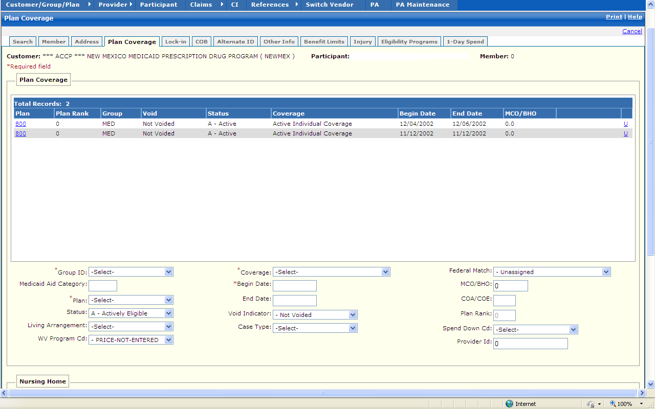

New Mexico PDCS OS PLUS Participant Subsystem
Window Exhibit
Participant Functional Group
Plan Coverage Tab Page
Field Name | Table  Column Name | Table Name | Format | Prot (A,C,N) | Req.  (A,C,N) | Std. Edits | Specifications | Note  Ref
Customer | R-CUST-PART-NUM | B_DETAIL_NM | 9,999 | A | N/A | N/A | Display Header
Participant | B_ALT_ID | B_ALT_ID_NM | Display | N | N | N/A | This is the single unique participant chosen from the results
Member | N/A | N/A | Display | A | N | N/A | Not captured for New Mexico .Always “1” for New Mexico .No multiple members.
Plan Coverage Display | Group | N/A | N/A | N/A | N/A | N/A | Grouping
Plan | R_PLAN_ID | B_PLAN_TB | X (3) | A | CN | N/A | Participant Plan ID
Plan Rank | N/A | N/A | N/A | N/A | N/A | N/A | Not captured for New Mexico .Defaulted to “0”
Group | R_GROUP_ID | B_PLAN_TB | X (8) | A | N | N/A | Participant Group
Void | B_PLAN_VD_IND | B_PLAN_TB | X (1) | A | N | N/A | Voided record indicator  Valid Values List 2670
Status | B_SUBSC_STAT_CD | B_PLAN_TB | X (1) | A | N | N/A | Default set to Actively Eligible .  Valid Values List 6695
Coverage | B_PLAN_CVRG_CD | B_PLAN_TB | X (2) | A | N | N/A | Master Plan Coverage Code  Defaults to “I”  Valid Values List 5654
Begin Date | B_CVRG_BEG_DT | B_PLAN_TB | DATE | A | N | N/A
End Date | B_CVRG_END_DT | B_PLAN_TB | DATE | A | N | N/A
MCO/BHO | B_BHO_MCO_NUM | B_PLAN_TB | 9(6) | A | N | N/A | Defaults to zero
Total Records | N/A | N/A | N/A | A | N | N/A | Computed as total number of plans
Plan Coverage  Entry | Group | N/A | N/A | N/A | N/A | N/A | Grouping
Group ID | R_GROUP_ID | B_PLAN_TB | Drop-down | A | A | N/A | Must be a unique group ID that has been defined in the Customer/Group/Plan Subsystem.
Medicaid Aid Category | B_AID_CTGRY_CD | B_PLAN_TB | 9(5) | A | C | N/AV | Must be a valid aid category included in the Plan for the Group  Valid Value list 9887
Plan | R_PLAN_ID | B_PLAN_TB | Drop-down | A | CA | N/A | Must be a unique plan ID associated with the Group.
Status | B_SUBSC_STAT_CD | B_PLAN_TB | Drop-down | A | CN | N/AV | Default set to Actively Eligible .  Valid Values List 6695
Living Arrangement | B_LV_ARRANGE_CD | B_PLAN_TB | Drop-down | C | C | N/AV | Valid Values List 993
WV Program Cd | B_WVR_PROG_CD | B_PLAN_TB | Drop-down | C | C | N/AV | Valid Values List 7615
Coverage | B_PLAN_CVRG_CD | B_PLAN_TB | Drop-down | A | A | N/AV | Valid Values List 5654
Begin Date | B_CVRG_BEG_DT | B_PLAN_TB | DATE | A | CA | N/AD | Must be a valid date
End Date | B_CVRG_END_DT | B_PLAN_TB | DATE | A | C | N/AD | Must be a valid date
Void Indicator | B_PLAN_VD_IND | B_PLAN_TB | Drop-down | A | CN | N/AV | Voided participant plan indicator  Valid Values List 9169
Case Type | B_CASE_TY_CD | B_PLAN_TB | Drop-down | C | C | N/AV | Valid Values List 2542
Federal Match | B_FED_MATCH_CD | B_PLAN_TB | Drop-down | A | N | N/AV | Valid Values List 2671
MCO/BHO | B_BHO_MCO_NUM | B_PLAN_TB | 9(6) | A | C | N/AN | Defaults to zero
COA/COE | B_COE_COA_CD | B_PLAN_TB | X (3) | A | C | N/A | The code indicates the reason the Participant is eligible for Medicaid.
Plan Rank | N/A | N/A | N/A | N/A | N/A | N/A | Not captured for New Mexico .Defaulted to “0”
Spend Down Cd: | B_SPDWN_CD | B_PLAN_TB | Drop-down | C | C | N/AV | Valid Values List 2603
Provider Id | P_ID | B_PLAN_TB | N | C | C | N/A | Provider ID
Nursing Home Display | Group | N/A | N/A | N/A | N/A | N/A | Grouping
Plan | R_PLAN_ID | B_PLAN_TB | X (3) | A | N/A | N/A | Participant Plan ID
Begin Date | B_CVRG_BEG_DT | B_PLAN_TB | DATE | A | N/A | N/A | Plan Begin Date
End Date | B_CVRG_END_DT | B_PLAN_TB | DATE | A | N/A | N/A | Plan End Date
Total Records | N/A | N/A | Display | A | N | N/A | Computed as total number of records

Legend
Prot. and Req. | Standard Edits | Note Ref.
A = Always | D = Date Edit | C = Customer-specific field or functionality
C = Conditionally | N = Numeric Edits | R = Note Reference
N = Never | S = System Generated
 | V = Valid Value Edit

Ref. No. | Notes
N/A | N/A

New Mexico PDCS OS PLUS Participant Subsystem
Window Specification
Participant Functional Group
Lock-In Tab Page

Window Name: Participant: Lock-In Tab
Description:
The Lock-In Tab Page window lists current, future, and historical periods of time during which a participant is restricted to a specific pharmacy to fill prescriptions, or to a specific dentist, physician, or group practice to write prescriptions.

The ID of the pharmacy or prescriber must exist on the PDCS OS PLUS Provider subsystem with an appropriate type code.

A voided span is ignored by claims processing.

Window Type:
Response window

Navigation:
The user enters this window by selecting the Lock-In tab from any of the Participant Subsystem windows.

Interface to other subsystem(s):
N/A

Interface to other Application(s):
Participant data is entered and maintained on the OmniCaid MMIS for New Mexico .When a Participant record is searched, PDCSOS PLUS sends a realtime eligibility request to the MMIS, and Participant data within PDCSOS PLUS is then populated based on the MMIS participant eligibility records.

Special Security Requirements:
N/A

Presentation Sequence(s):
The records are displayed in ascending sequence by Lock-In Type code, begin date, provider ID, and end date .

Remarks:
Participant data is entered and maintained on the OmniCaid MMIS for New Mexico. All data within the PDCSOS PLUS Participant subsystem for NEWMEX and NMENCO is read-only.

New Mexico PDCS OS PLUS Participant Subsystem
Window Layout
Participant Functional Group
Lock-In Tab Page

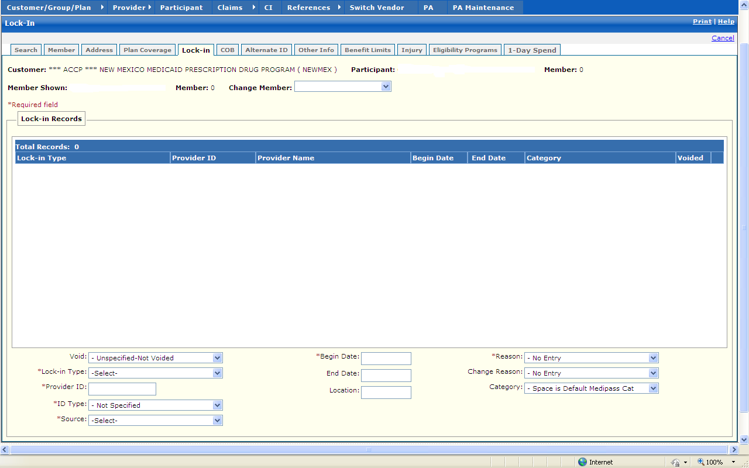

New Mexico PDCS OS PLUS Participant Subsystem
Window Exhibit
Participant Functional Group
Lock-In Tab Page
Field Name | Table  Column Name | Table Name | Format | Prot (A,C,N) | Req.  (A,C,N) | Std. Edits | Specifications | Note  Ref
Customer | R-CUST-PART-NUM | B_DETAIL_NM | 9,999 | A | N/A | N/A | Display Header
Participant | B_ALT_ID | B_ALT_ID_NM | Display | N | N | N/A | This is the single unique participant chosen from the results
Member | N/A | N/A | Display | A | N | N/A | Not captured for New Mexico .Always “1” for New Mexico .No multiple members.
Member Shown | N/A | N/A | N/A | N/A | N/A | N/A | N/A
Member | N/A | N/A | N/A | N/A | N/A | N/A | N/A
Change Member | N/A | N/A | N/A | N/A | N/A | N/A | N/A
Lock-In Records Display | Group | N/A | N/A | N/A | N/A | N/A | Grouping
Lock-in Type | B_LCKN_TY_CD | B_LOCKIN_TB | Drop-down | A | N | N/A
Provider ID | P_ID | B_LOCKIN_TB | Integer | A | N | N/A | Use P-ID to search the PXREFTB and display the P-ALT-ID.
Provider Name | P_NAM | P_PROV_TB | X (35) | A | N | N/A | Name of Provider the participant is Locked-in to
Begin Date | B_LCKN_BEG_DT | B_LOCKIN_TB | DATE | A | N | N/A
End Date | B_LCKN_END_DT | B_LOCKIN_TB | DATE | A | N | N/A
Category | B_LCKN_CAT_CD | B_LOCKIN_TB | X (1) | A | N | N/A | Defaults to space.
Total Records | N/A | N/A | Display | A | N | N/A | Computed as total number of lock-in records
Lock-In Records Entry | Group | N/A | N/A | N/A | N/A | N/A | Grouping
Void | B_LCKN_VD_IND | B_LOCKIN_TB | Drop-down | A | N | N/AV | Void record indicator  Valid Values List 5672
Lock-in Type | B_LCKN_TY_CD | B_LOCKIN_TB | Drop-down | A | A | N/AV | This code describes the Medicaid health care model the participant is locked-in to .  Valid Values List 0036
Provider ID | P_ID | B_LOCKIN_TB | X (9) | A | CA | N/A | Use P-ID to search the PXREFTB and display the P-ALT-ID.
ID Type | P_ALT_ID_CD | P_XREF_TB | X (2)  Drop-down | A | CA | N/AV | Valid Values List 2325  Note: uses Provider code sets
Source | P_ALT_ID_TYP_CD | P_XREF_TB | X (6)  Drop-down | AA | CA | N/AV | Valid Values List 0486  Note: uses Provider code sets
Begin Date | B_LCKN_BEG_DT | B_LOCKIN_TB | DATE | A | CA | N/AD | Must be valid date
End Date | B_LCKN_END_DT | B_LOCKIN_TB | DATE | A | C | N/AD | Must be a valid date
Location | B_LCKN_LOCN_CD | B_LOCKIN_TB | X (9) | A | N | N/A | Location Code for HMO.
Reason | B_LCKN_ASGN_RSN_  CD | B_LOCKIN_TB | Drop-down | A | A | N/AV | The reason the participant was locked-in to the health care model.  Valid Values List 1440
Change Reason | B_LCKN_CHNG_RSN_  CD | B_LOCKIN_TB | Drop-down | AA | CN | N/AV | The reason the participant was disenrolled from the health care model.  Valid Values List 0207
Category | B_LCKN_CAT_CD | B_LOCKIN_TB | Drop-down | A | N | N/AV | Valid Values List 9363

Legend
Prot. and Req. | Standard Edits | Note Ref.
A = Always | D = Date Edit | C = Customer-specific field or functionality
C = Conditionally | N = Numeric Edits | R = Note Reference
N = Never | S = System Generated
 | V = Valid Value Edit

Ref. No. | Notes
N/A | N/A

New Mexico PDCS OS PLUS Participant Subsystem
Window Specification
Participant Functional Group
Coordination of Benefits Tab Page

Window Name: Participant: COB Tab
Description:
The Coordination of Benefits (COB) window lists current, future, and historical information spans regarding other insurance coverage for the participant .COB is also known as Third Party Liability (TPL) .

Included on this window are the carrier ID, carrier name, policy number, policy type, and begin and end dates of coverage with this carrier .

Voided spans is ignored by claims processing.

Window Type:
Response window

Navigation:
The user enters this window by selecting the COB tab from any of the Participant Subsystem windows.

Interface to other subsystem(s):
N/A

Interface to other Application(s):
Participant data is entered and maintained on the OmniCaid MMIS for New Mexico .When a Participant record is searched, PDCSOS PLUS sends a realtime eligibility request to the MMIS, and Participant data within PDCSOS PLUS is then populated based on the MMIS participant eligibility records.

Special Security Requirements:
N/A

Presentation Sequence(s):
The records are displayed in carrier ID sequence.

Remarks:
Participant data is entered and maintained on the OmniCaid MMIS for New Mexico. All data within the PDCSOS PLUS Participant subsystem for NEWMEX and NMENCO is read-only.

New Mexico PDCS OS PLUS Participant Subsystem
Window Layout
Participant Functional Group
Coordination of Benefits Tab Page

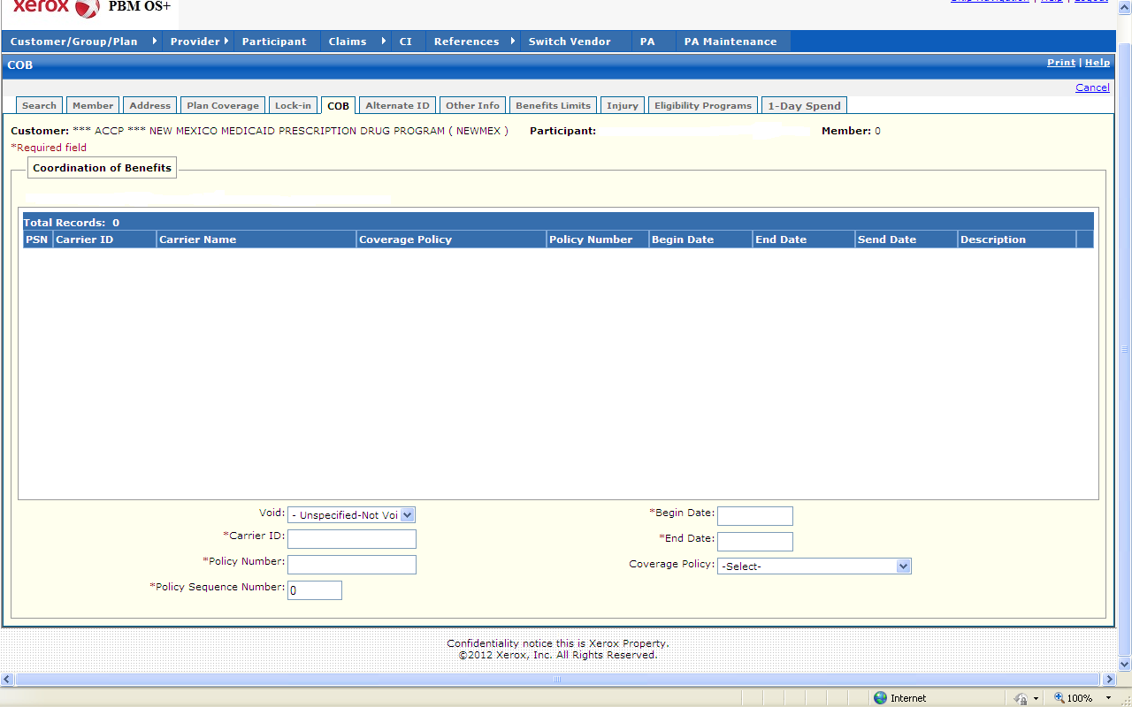

New Mexico PDCS OS PLUS Participant Subsystem
Window Exhibit
Participant Functional Group
Coordination of Benefits Tab Page
Field Name | Table  Column Name | Table Name | Format | Prot (A,C,N) | Req.  (A,C,N) | Std. Edits | Specifications | Note  Ref
Customer | R-CUST-PART-NUM | B_DETAIL_NM | 9,999 | A | N/A | N/A | Display Header
Participant | B_ALT_ID | B_ALT_ID_NM | Display | N | N | N/A | This is the single unique participant chosen from the results
Member | N/A | N/A | Display | A | N | N/A | Not captured for New Mexico .Always “1” for New Mexico .No multiple members.
Coordination of Benefits Display | Group | N/A | N/A | N/A | N/A | N/A | Grouping
PSN | T_PLCY_SEQ_NUM | T_CVRG_CLNT_TB | 9999 | A | CN | N/A | Policy Sequence Number
Carrier ID | T_CARR_ID | T_CVRG_CLNT_TB | X (10) | A | N | N/A | Carrier ID of the participant’s third party insurer.
Carrier Name | T_CARR_NAM | TCARRITB | X (40) | A | N | N/A | Carrier Name of the participant’s third party insurer.
Coverage Policy | T_CVRG_PLCY_CD | T_CVRG_CLNT_TB | X (2) | A | N | N/A | Policy Code of the participant’s third party insurer.  Valid Values List 2558
Policy Number | T_PLCY_NUM | T_CVRG_CLNT_TB | X (20) | A | N | N/A | Policy number of the participant’s third party insurer.
Begin Date | T_CVRG_CLNT_BEG  _DT | T_CVRG_CLNT_TB | DATE | A | N | N/A | Participant’s policy begin date .Must be less than or equal to the policy end date.
End Date | T_CVRG_CLNT_END  _DT | T_CVRG_CLNT_TB | DATE | A | N | N/A | Participant’s policy begin date .Must be greater than or equal to the policy begin date.
Description | N/A | N/A | N/A | N/A | N/A | N/A | Not captured for New Mexico .
Total Records | N/A | N/A | N/A | A | N | N/A | Computed as total number of coordination of benefits records
Coordination of Benefits Entry | Group | N/A | N/A | N/A | N/A | N/A | Grouping
Void | T_PART_VOID_IND | T_CVRG_CLNT_TB | Drop-down | AA | N | N/AV | Voided record indicator  Valid Values List 4721
Carrier ID | T_CARR_ID | T_CVRG_CLNT_TB | X (10) | A | CA | N/A | Carrier ID of the participant’s third party insurer.
Policy Number | T_PLCY_NUM | T_CVRG_CLNT_TB | X (20) | AA | CA | N/A | Policy number of the participant’s third party insurer.
Policy Sequence Number | T_PLCY_SEQ_NUM | T_CVRG_CLNT_TB | 9999 | A | CA | N/A | Policy Sequence Number
Begin Date | T_CVRG_CLNT_BEG  _DT | T_CVRG_CLNT_TB | DATE | A | CA | N/AN/A | Participant’s policy begin date .Must be less than or equal to the policy end date.  Must be a valid date
End Date | T_CVRG_CLNT_END  _DT | T_CVRG_CLNT_TB | DATE | A | CA | N/AN/A | Participant’s policy begin date .Must be greater than or equal to the policy begin date.  Must be a valid date
Coverage Policy | T_CVRG_PLCY_CD | T_CVRG_CLNT_TB | Drop-down | A | N | N/AV | TPL coverage policy codes.  Valid Values List 2558

Legend
Prot. and Req. | Standard Edits | Note Ref.
A = Always | D = Date Edit | C = Customer-specific field or functionality
C = Conditionally | N = Numeric Edits | R = Note Reference
N = Never | S = System Generated
 | V = Valid Value Edit

Ref. No. | Notes
N/A | N/A

New Mexico PDCS OS PLUS Participant Subsystem
Window Specification
Participant Functional Group
Alternate ID Tab Page

Window Name: Participant: Alternate ID Tab
Description:
The Alternate ID pane lists any and all alternate identifiers that are associated with the participant’s system ID .The alternate ID may be numeric, alphabetic, or a combination of both .The Reporting ID defined on this window is the ID used for the submission of pharmacy claims.

Window Type:
Response window

Navigation:
The user enters this window by selecting the Alternate ID tab from any of the Participant Subsystem windows.

Interface to other subsystem(s):
N/A

Interface to other Application(s):
Participant data is entered and maintained on the OmniCaid MMIS for New Mexico .When a Participant record is searched, PDCSOS PLUS sends a realtime eligibility request to the MMIS, and Participant data within PDCSOS PLUS is then populated based on the MMIS participant eligibility records.

Special Security Requirements:
N/A

Presentation Sequence(s):
Alternate IDs are displayed in ID sequence .

Remarks:
Participant data is entered and maintained on the OmniCaid MMIS for New Mexico. All data within the PDCSOS PLUS Participant subsystem for NEWMEX and NMENCO is read-only.

Note that the ID Cards pane was designed for those Customers for whom Conduent performs card production .This pane is not being utilized for New Mexico and details on its fields are not included within the Windows Exhibit.

New Mexico PDCS OS PLUS Participant Subsystem
Window Layout
Participant Functional Group
Alternate ID Tab Page

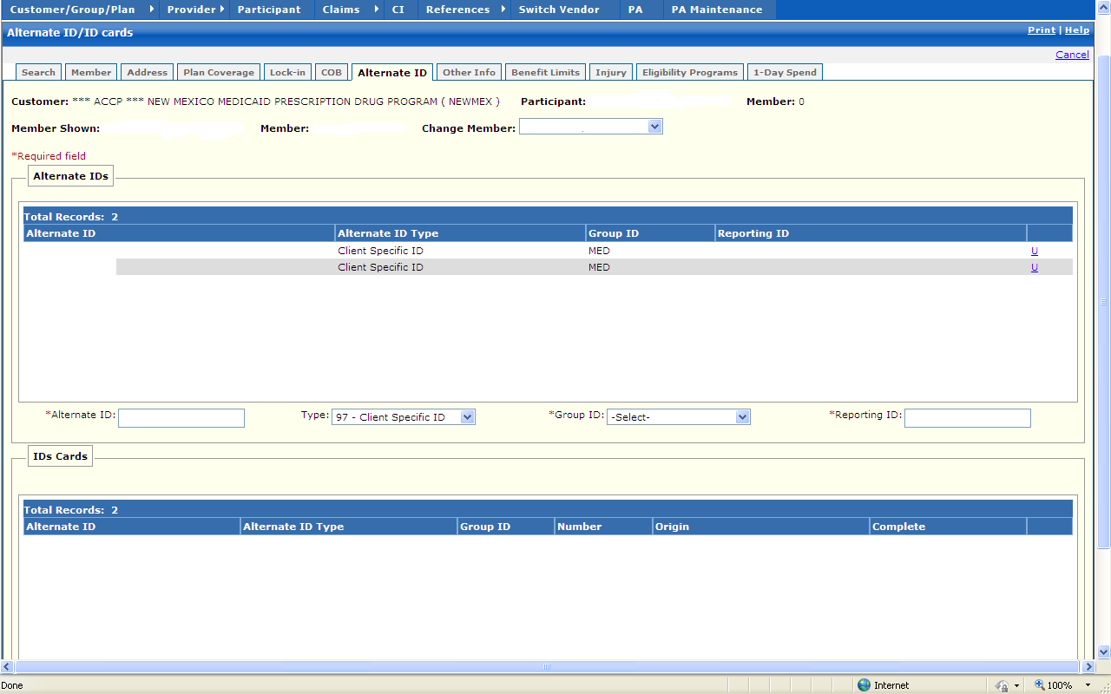

New Mexico PDCS OS PLUS Participant Subsystem
Window Exhibit
Participant Functional Group
Alternate ID Tab Page
Field Name | Table  Column Name | Table Name | Format | Prot (A,C,N) | Req.  (A,C,N) | Std. Edits | Specifications | Note  Ref
Customer | R-CUST-PART-NUM | B_DETAIL_NM | 9,999 | A | N/A | N/A | Display Header
Participant | B_ALT_ID | B_ALT_ID_NM | Display | N | N | N/A | This is the single unique participant chosen from the results
Member | N/A | N/A | Display | A | N | N/A | Not captured for New Mexico .Always “1” for New Mexico .No multiple members.
Member Shown | N/A | N/A | N/A | N/A | N/A | N/A | N/A
Member | N/A | N/A | N/A | N/A | N/A | N/A | N/A
Change Member | N/A | N/A | N/A | N/A | N/A | N/A | N/A
Alternate IDs Display | Group | N/A | N/A | N/A | N/A | N/A | Grouping
Alternate ID | B_ALT_ID | B_ALT_ID_TB | X (20) | A | N | N/A | Click on the link for each ID to view details on alternate participant IDs assigned to the current participant.
Alternate ID Type | B_ALT_ID_CD | B_ALT_ID_TB | X (30) | A | N | N/A | Qualifier associated with the Participant IDs  Values List 0255
Group ID | R_GROUP_ID | B_ALT_ID_TB | X (8) | A | N | N/A | Group that that the ID is associated with.
Reporting ID | B_RPT_ALT_ID | B_ALT_ID_TB | X (20) | A | N | N/A
Total Records | N/A | N/A | N/A | A | N | N/A | Computed as total number of alternate ID records.
Alternate IDs Entry | Group | N/A | N/A | N/A | N/A | N/A | Grouping
Alternate ID | B_ALT_ID | B_ALT_ID_TB | X (20) | A | CA | N/A | The participant’s selected alternate ID from the search results panel above.
Type | B_ALT_ID_CD | B_ALT_ID_TB | Drop-down | AA | N | N/AV | Qualifier associated with the Participant IDs  Values List 0255
Group ID | R_GROUP_ID | B_ALT_ID_TB | Drop-down | AA | A | N/A | Group with which the ID is associated.
Reporting ID | B_RPT_ALT_ID | B_ALT_ID_TB | X (20) | A | CA | N/A
ID Cards Display | Group | N/A | N/A | N/A | N/A | N/A | Grouping
Alternate ID | b_alt_id | B_DRUG_REQ_TB | Display | A | N | N/A | Alternate participant IDs assigned to the participant based on the Alternate id type.
Alternate ID Type | b_alt_id_cd | B_DRUG_REQ_TB | Display | A | N | N/A | Alternate
Group ID | r_group_id | B_DRUG_REQ_TB | Display | A | N | N/A | Group that that the ID is associated with.
Number | b_card_req_num | B_DRUG_REQ_TB | Display | A | N | N/A
Origin | B_REQ_ORGNTN_CD | B_DRUG_REQ_TB | Display | A | N | N/A
Complete | b_req_cmpl_ind | B_DRUG_REQ_TB | Display | A | N | N/A | Indicator
Total Records | N/A | N/A | N/A | A | N | N/A | Computed as total number of ID card records.
ID Cards Entry | Group | N/A | N/A | N/A | N/A | N/A | Grouping
Alternate ID | b_alt_id | B_DRUG_REQ_TB | X(20) | N | C | N | Alternate ID Type is a qualifier associated with the Participant IDs
Group ID | r_group_id | B_DRUG_REQ_TB | X(8) | N | A | V | Group that that the ID is associated with.
Number | b_card_req_num | B_DRUG_REQ_TB | SMALLINT | N | A | N

Legend
Prot. and Req. | Standard Edits | Note Ref.
A = Always | D = Date Edit | C = Customer-specific field or functionality
C = Conditionally | N = Numeric Edits | R = Note Reference
N = Never | S = System Generated
 | V = Valid Value Edit

Ref. No. | Notes
N/A | N/A

New Mexico PDCS OS PLUS Participant Subsystem
Window Specification
Participant Functional Group
Other Info Tab Page

Window Name: Participant: Other Info Tab
Description:
The Other Info tab page was designed to accommodate Inferred Disease and Spend Down programs .This window is not being utilized for New Mexico.

Window Type:
Response window

Navigation:
The user enters this window by selecting the Other Info tab from any of the Participant Subsystem windows.

Interface to other subsystem(s):
N/A

Interface to other Application(s):
N/A

Special Security Requirements:
N/A

Presentation Sequence(s):
N/A

Remarks:
Note that no Window Exhibit section is provided for this window, as data is not being populated on this window for New Mexico.

New Mexico PDCS OS PLUS Participant Subsystem
Window Layout
Participant Functional Group

Other Info Tab Page

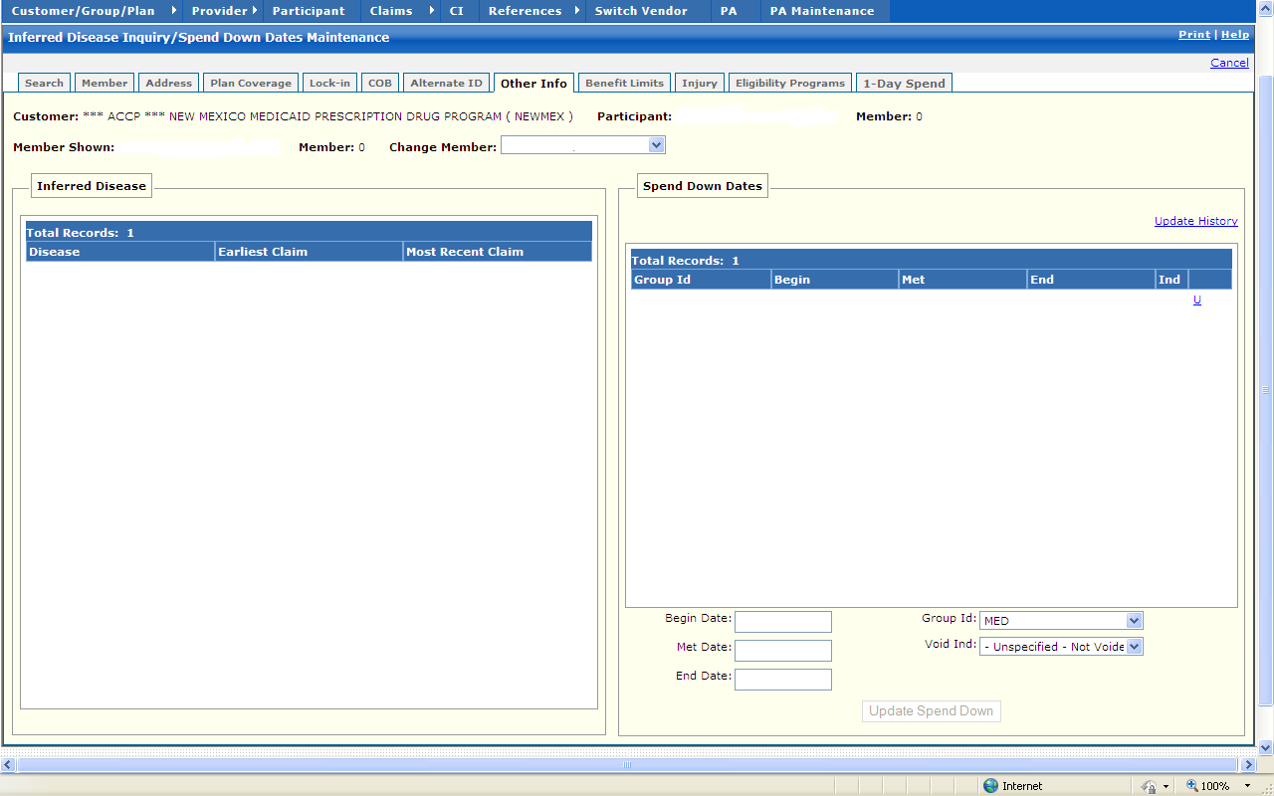

New Mexico PDCS OS PLUS Participant Subsystem
Window Specification
Participant Functional Group
Benefit Limits Tab Page

Window Name: Participant: Benefit Limits Tab
Description:
The Benefit Limits tab page contains on-demand calculated information concerning the dollar amount a participant has used for their pharmacy benefit and how much of the benefit remains, if it is capped .This window shows the status of the participant’s deductibles and maximum benefit limits as of a user-defined point in time .The user selects a month, day, and/or year to check used and remaining amounts, and then clicks the Show Benefit Limits button .

The Benefits Limits fields are populated with the limit information as of the point in time selected by the user .This information is for display only .

The amounts shown on this page are calculated using the following logic:
- PDCSOS PLUS examines the entered date from the benefit limits search section and checks for concurrent plan coverage information.
- Then the system retrieves all claim information from the start of the fiscal year to the searched-upon date.
- Then the system examines the participant’s benefit and deductible coverages .
- From this data, PDCSOS PLUS then calculates remaining balances, deductibles, or monthly remaining amounts.

Window Type:
Response window

Navigation:
The user enters this window by selecting the Benefit Limits tab from any of the Participant Subsystem windows.

Interface to other subsystem(s):
The benefit limits fields are dynamically accumulated from the Claims subsystem.

Interface to other Application(s):
Participant data is entered and maintained on the OmniCaid MMIS for New Mexico .When a Participant record is searched, PDCSOS PLUS sends a realtime eligibility request to the MMIS, and Participant data within PDCSOS PLUS is then populated based on the MMIS participant eligibility records.

Special Security Requirements:
N/A

Presentation Sequence(s):
N/A

Remarks:
Participant data is entered and maintained on the OmniCaid MMIS for New Mexico. All data within the PDCSOS PLUS Participant subsystem for NEWMEX and NMENCO is read-only.
New Mexico PDCS OS PLUS Participant Subsystem
Window Layout
Participant Functional Group

Benefit Limits Tab Page

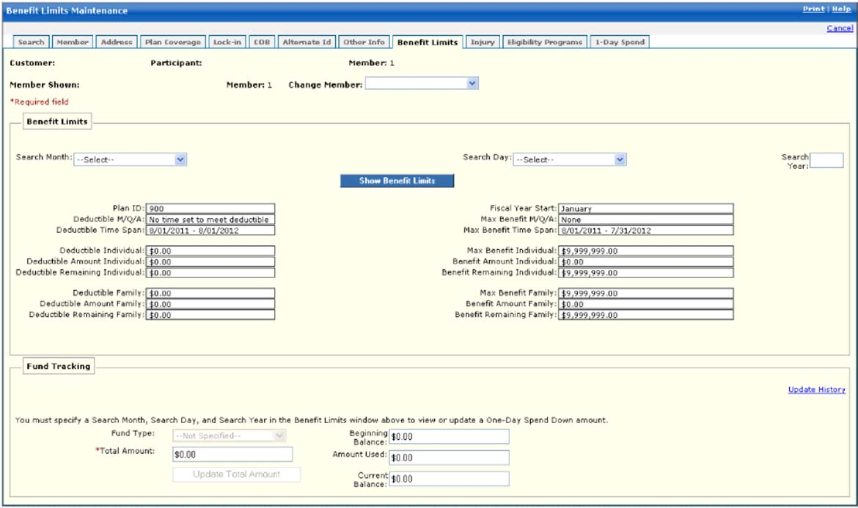

New Mexico PDCS OS PLUS Participant Subsystem
Window Exhibit
Participant Functional Group
Benefit Limits Tab Page
Field Name | Table  Column Name | Table Name | Format | Prot (A,C,N) | Req.  (A,C,N) | Std. Edits | Specifications | Note  Ref
Customer | R-CUST-PART-NUM | B_DETAIL_NM | 9,999 | A | N/A | N/A | Display Header
Participant | B_ALT_ID | B_ALT_ID_NM | Display | N | N | N/A | This is the single unique participant chosen from the results
Member | N/A | N/A | Display | A | N | N/A | Not captured for New Mexico .Always “1” for New Mexico .No multiple members.
Member Shown | N/A | N/A | N/A | N/A | N/A | N/A | N/A
Member | N/A | N/A | N/A | N/A | N/A | N/A | N/A
Change Member | N/A | N/A | N/A | N/A | N/A | N/A | N/A
Benefit Limits Search | Group | N/A | N/A | N/A | N/A | N/A | Grouping
Search Month | N/A | N/A | Drop-down | N | N | N/A | Month section used to refine benefit limit search .The participant must have an active benefit plan that covers the selected month, day and year.
Search Day | N/A | N/A | Drop-down | N | N | N/A | Day section used to refine benefit limit search .The participant must have an active benefit plan that covers the selected month, day and year.
Search Year | N/A | N/A | Text Entry | NN | AC | N/A | Four digit year used to refine benefit limit search .The participant must have an active benefit plan that covers the selected month, day and year.
Command Button | Group | N/A | N/A | N/A | N/A | N/A | Grouping
Show Benefit Limits | N/A | N/A | Push Button | N | N/A | N/A | When selected, the participant’s Benefits Limit Record that is effective for the selected date range is displayed.
Benefit Limits Display | Grouping |  | Grouping | N/A | N/A | N/A | Grouping
Plan ID | R_PLAN_ID | B_PLAN_TB | X3) | A | CN | N/A | Plan ID of the benefit limits being shown based on the entered search date.
Deductible M/Q/A | R_DED_ACUM_CD | R_PLAN_DTL_TB | X (1) | A | N | VN/A | Deductible accumulator indicator shows whether a deductible must be met monthly, quarterly or annually.  Note: Valid values list in Reference code sets.  Valid Values 3406
Deductible Time Span | N/A | N/A | N | A | N | N/A | Computed
Deductible Individual | R_DED_INDIV_AMT | R_PLAN_DTL_TB | N | A | N | N/A | Dollar amount that must be paid by member before their pharmacy benefit becomes effective.
Deductible Amount Individual | N/A | N/A | N | A | N | N/A | Computed from claim data
Deductible Remaining Individual | N/A | N/A | N | A | N | N/A | Computed as Deductible Individual – Deductible Amount Individual
Deductible Family | R_DED_FAM_AMT | R_PLAN_DTL_TB | N | A | N | N/A | Family deductible is the dollar amount that must be paid by a family before the pharmacy benefit becomes effective.
Deductible Amount Family | N/A | N/A | N | A | N | N/A | Computed from claim data
Deductible Remaining Family | N/A | N/A | N | A | N | N/A | Computed as Deductible Family – Deductible Amount Family
Fiscal Year Start | R_FY_BEG_MO_NUM | R_PLAN_DTL_TB | 9999 | A | N | N/A | Month when benefit plan’s fiscal year begins.
Max Benefit M/Q/A | R_MAX_BENE_ACUM_CD | R_PLAN_DTL_TB | X (1) | A | N | VN/A | Indicates whether the maximum benefit is met monthly, quarterly, or annually.  Note: Valid values list in Reference code sets.  Valid values 7822
Max Benefit Time Span | N/A | N/A | N | A | N | N/A | Computed
Max Benefit Individual | R_MAX_INDIV_AMT | R_PLAN_DTL_TB | N | A | N | N/A | Maximum dollar amount determined by the plan for an individual.
Benefit Amount Individual | N/A | N/A | N | A | N | N/A | Computed from claim data
Benefit Remaining Individual | N/A | N/A | N | A | N | N/A | Computed as Max Benefit Individual – Benefit Amount Individual
Max Benefit Family | R_MAX_FAM_AMT | R_PLAN_DTL_TB | N | A | N | N/A | Maximum dollar amount determined by the plan for all family members covered.
Benefit Amount Family | N/A | N/A | N | A | N | N/A | Computed from claim data
Benefit Remaining Family | N/A | N/A | N | A | N | N/A | Computed as Max Benefit Family – Benefit Amount Family
Fund Tracking | Group | N/A | N/A | N/A | N/A | N/A | Grouping
Fund Type | B_FUND_TY_CD | B_FUND_TRACKING_TB | Drop-down | N/A | N/A | N/AV | Valid List Values 1509
Total Amount | B_FUND_TOT_AMT | B_FUND_TRACKING_TB | N | A | N | N/A | Used to manually update the Fund Tracking table.
Command Button | Group | N/A | N/A | N/A | N/A | N/A | Grouping
Update Total Amount | N/A | N/A | Push Button | A | N/A | N/A | Used to manually update the Fund Tracking table.
Beginning Balance | B_FUND_BEG_BAL_AMT | B_FUND_TRACKING_TB | N | A | N | N/A | Used to manually update the Fund Tracking table.
Amount Used | B_FUND_ADJUD_AMT | B_FUND_TRACKING_TB | N | A | N | N/A | Used to manually update the Fund Tracking table.
Current Balance | B_FUND_END_BAL_AMT | B_FUND_TRACKING_TB | N | A | N | N/A | Used to manually update the Fund Tracking table.

Legend
Prot. and Req. | Standard Edits | Note Ref.
A = Always | D = Date Edit | C = Customer-specific field or functionality
C = Conditionally | N = Numeric Edits | R = Note Reference
N = Never | S = System Generated
 | V = Valid Value Edit

Ref. No. | Notes
C1 | Data is not maintained within the B_FUND_TRACKING_TB table for New Mexico, so there is no need to be able to manually update account balances (this functionality is used to update balance information for Conduent’s Senior Pharmacy Benefit Programs) .  As described in the Window Specification for this tab page, information shown on this window is calculated by PDCSOS PLUS based on the search date entered by the user.

New Mexico PDCS OS PLUS Participant Subsystem
Window Specification
Participant Functional Group
Injury Tab Page

Window Name: Participant: Injury Tab
Description:
The Injury tab page is used for Conduent’s Worker’s Compensation Customers .This window is not being utilized for New Mexico.

Window Type:
Response window

Navigation:
The user enters this window by selecting the Injury tab from any of the Participant Subsystem windows.

Interface to other subsystem(s):
N/A

Interface to other Application(s):
N/A

Special Security Requirements:
N/A

Presentation Sequence(s):
N/A

Remarks:
Note that no Window Exhibit section is provided for this window, as data is not being populated on this window for New Mexico.

New Mexico PDCS OS PLUS Participant Subsystem
Window Layout
Participant Functional Group

Injury Tab Page

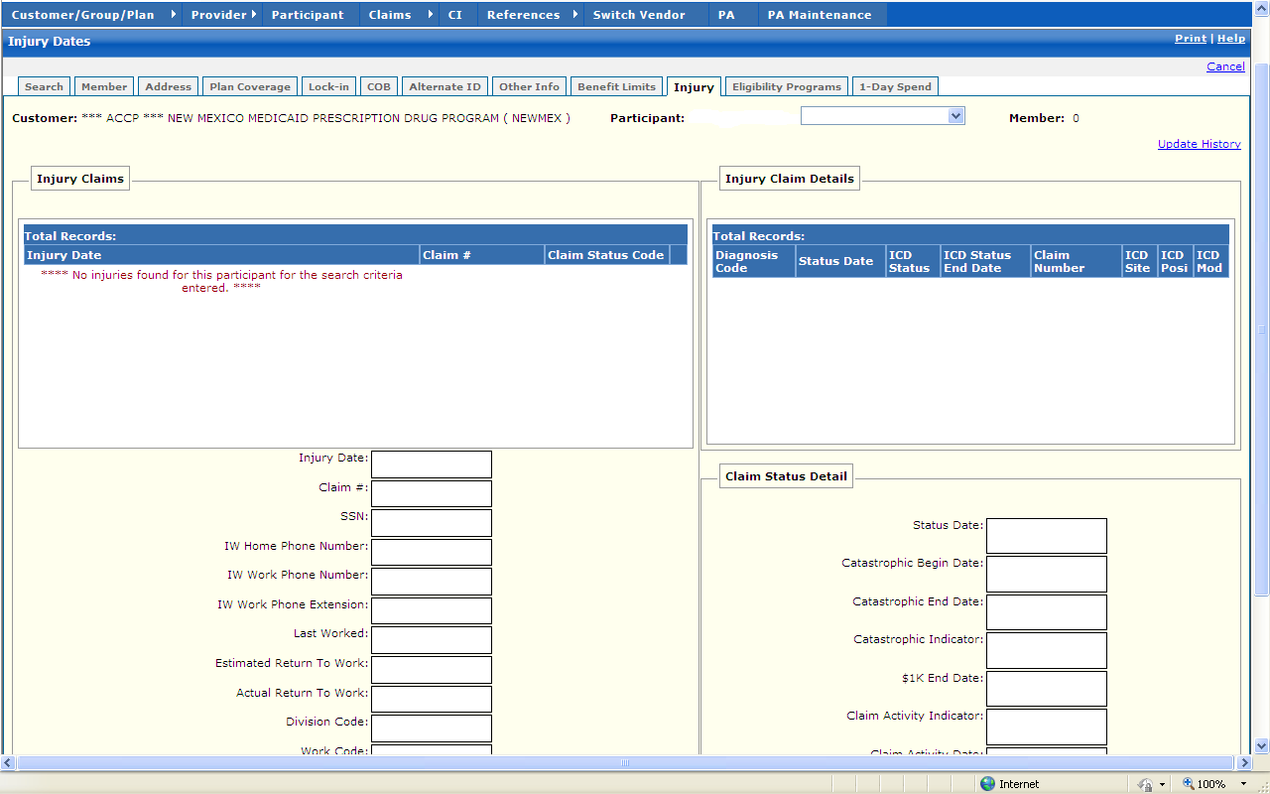
New Mexico PDCS OS PLUS Participant Subsystem
Window Specification
Participant Functional Group
Eligibility Programs Tab Page

Window Name: Participant: Eligibility Programs Tab
Description:
The Eligibility programs tab page is used by Conduent’s customers with special eligibility requirements .This window is not being utilized for New Mexico.

Window Type:
Response window

Navigation:
The user enters this window by selecting the Eligibility Programs tab from any of the Participant Subsystem windows.

Interface to other subsystem(s):
N/A

Interface to other Application(s):
N/A

Special Security Requirements:
N/A

Presentation Sequence(s):
N/A

Remarks:
Note that no Window Exhibit section is provided for this window, as data is not being populated on this window for New Mexico.

New Mexico PDCS OS PLUS Participant Subsystem
Window Layout
Participant Functional Group

Eligibility Programs Tab Page



